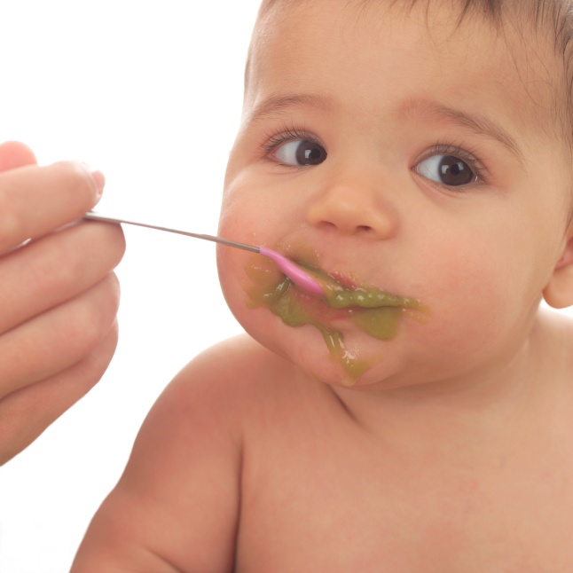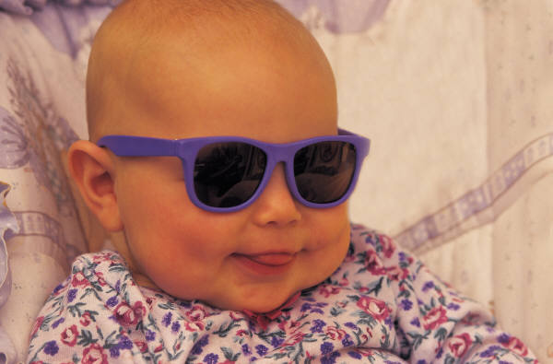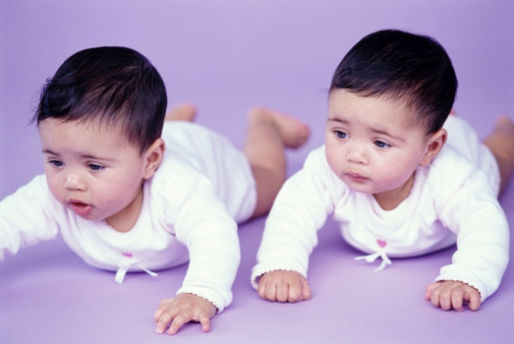

Have drivers license

Will cook meals

Available nights & weekends

CPR Certified

YMCA Certified

Name

Phone Number

Name

Phone Number

Name

Phone Number

Name

Phone Number

Name

Phone Number

Name

Phone Number

Name

Phone Number

Name

Phone Number

Name

Phone Number

Name

Phone Number

Name

Phone Number

Name

Phone Number

Name

Phone Number

Name

Phone Number

**Contact (Name)at (555) 555-0125**

**$7.00/hR**

BABYSITTING

Name

Phone Number

Name

Phone Number

Name

Phone Number

Name

Phone Number